Meeting Minutes – Group 2

**Meeting No:** 1

**Location:** Room 111

**Date:** 12 May 2015

**Time:** 45 minutes

**Reporter**: Đinh Quang Trung

## Attendance

(Gạch tên nếu vắng mặt)

1. Kiều Trọng Khánh
2. Đinh Quang Trung
3. Nguyễn Hữu Phúc
4. Phùng Quang Minh Trí
5. Nguyễn Chí Kha

## Action Items

(Tất cả các vấn đề đã thảo luận trong buổi họp)

1. Project Core Flow from Mr. Khanh

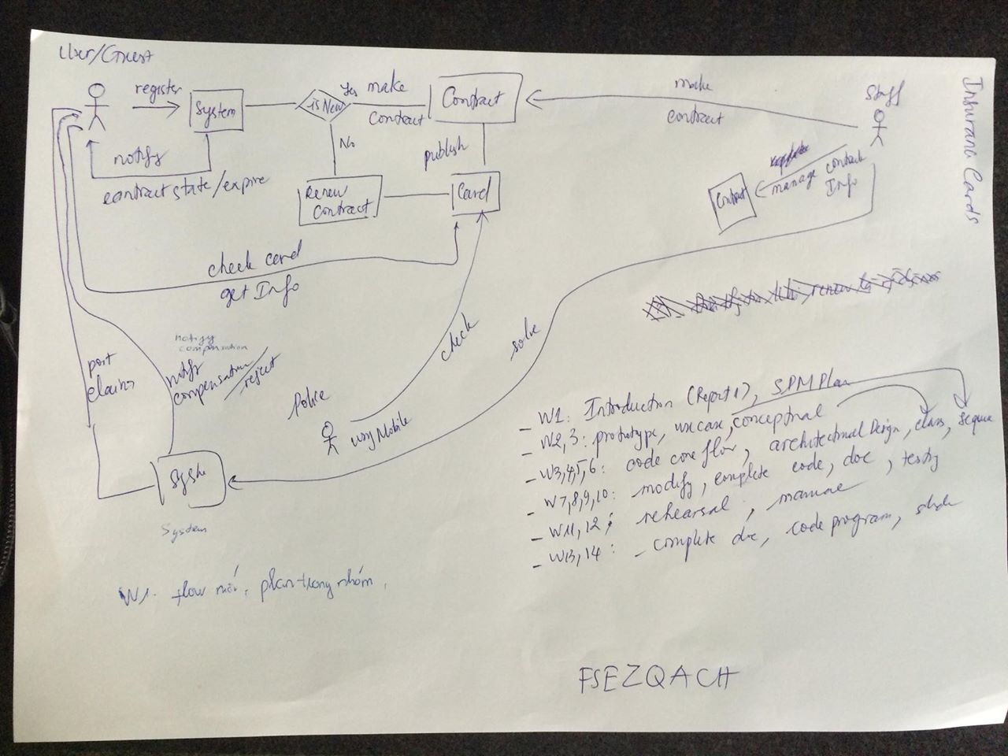

1. Project Plan for 14 weeks

Check scope frequently to know if the features requested from supervisor is enough.

1. Discuss about security in NFC card

Use low level ID to secure customer information

1. Project components: 1 webapp, 1 mobile app for traffic police officer, 1 mobile app for staff to print cards.
2. Questions and answers about project business.
3. Next deadline: 14 May: submit report 1 to Mr. Khanh.
4. Pass Enroll: FSEZQACH
5. Questions for next meeting:
6. Do we need register feature? When user register, they will not receive their account yet but will wait for a staff to approve and make a contract with them. After the contract is signed, the staff will send a username/password to the user. Is this a good flow?
7. Link tracking project for Mr. Khanh: <https://github.com/trungdq88/insurance-card/commits/master>  
   Submit report 1, SPM plan.
8. In original requirement, there is a feature that police officer will be able to send punishment of violator to the system. So we need to add this feature to the Checker mobile app (app for police officers)?